Ex. No. 10 | Spring Boot
Github Code Link | https://github.com/DeepakKrishnanSU/Spring-Boot.git
Aim
To develop a full-stack web application using Spring Boot, Spring MVC, Spring Data JPA, Hibernate, and PostgreSQL to implement CRUD operations (Add, View, Update, Delete) and search functionality with dynamic JSP views.
Description
Spring Boot is an opinionated framework built on top of the Spring Framework that simplifies the bootstrapping and development of stand-alone, production-grade applications with embedded server support and zero XML configuration. In this application, a layered architecture is adopted comprising the Presentation Layer (Spring MVC Controller and JSP views), Service Layer (business logic and transaction management), and Persistence Layer (Spring Data JPA with Hibernate ORM). Spring Boot auto-configures the embedded Tomcat server and manages connection pooling to PostgreSQL via HikariCP. Full CRUD functionality is enabled through JpaRepository methods, permitting seamless student record insertion, modification, deletion, and case-insensitive searching. The application uses constructor-based dependency injection to achieve loose coupling and enhanced maintainability.
Program
// Full Program screenshot from Eclipse IDE [without black color background]
Output Screenshots
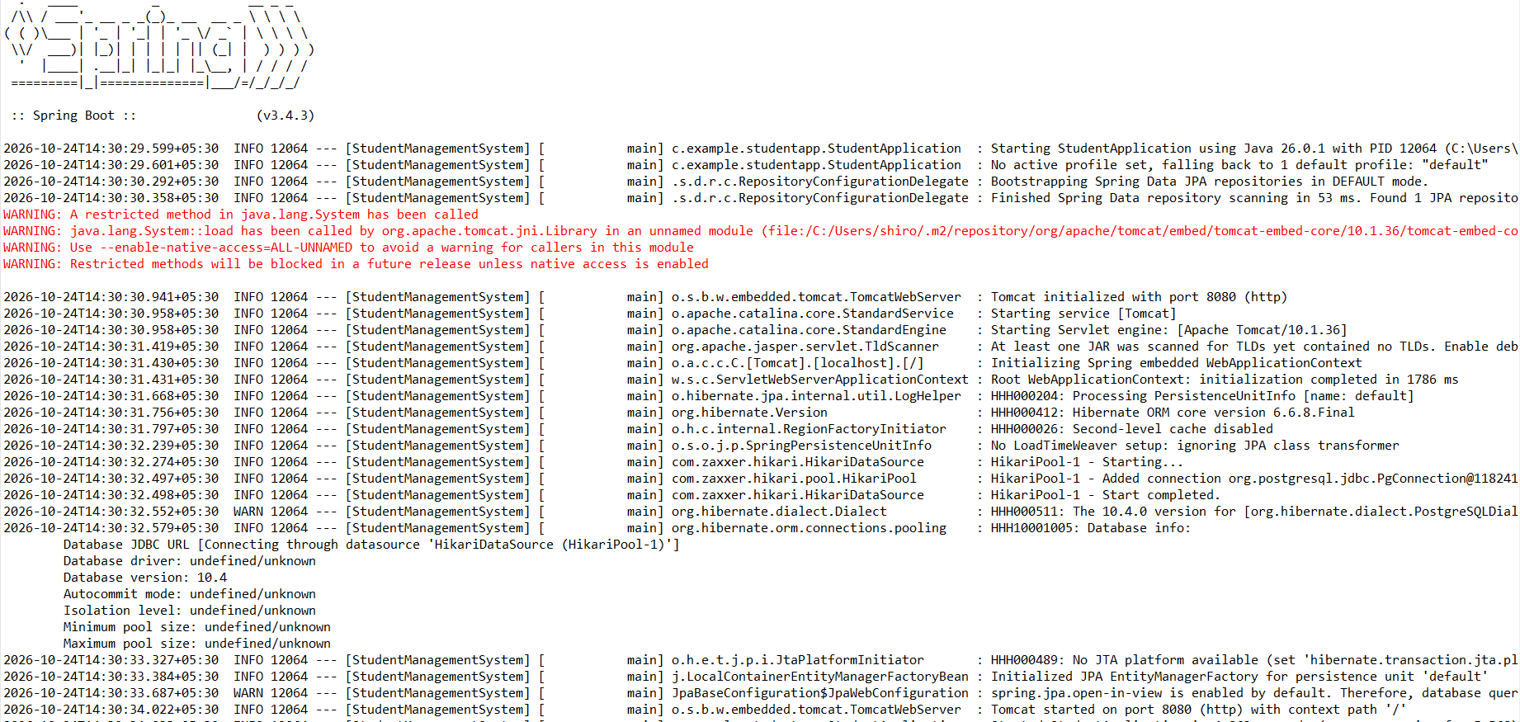
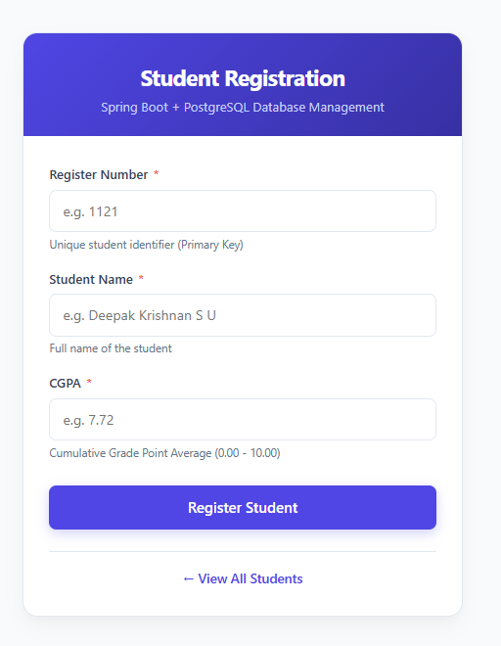
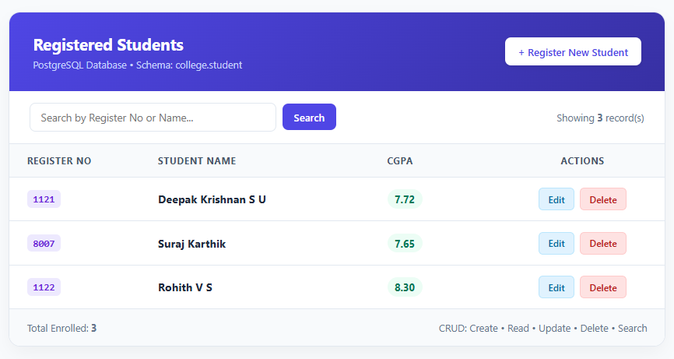
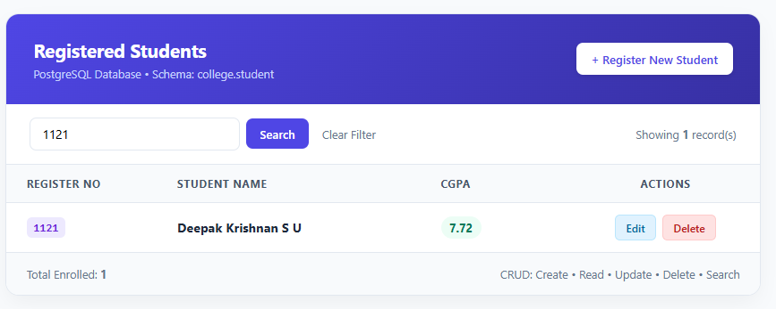
Result
Thus, the Student Management System was successfully developed and executed using Spring Boot, Spring MVC, Spring Data JPA, and PostgreSQL, fulfilling all CRUD operations and search requirements.

